EJHA Logo - small.pnglogo-ucs-small.pngDCR4EJ Logo - small.png

***\*\*\* For Release: Thursday, October 19th \*\*\****

**Contact:**

Seth Michaels, (202) 331-5662, [smichaels@ucsusa.org](mailto:smichaels@ucsusa.org)

Eric Whalen, (971) 998-8786, [EricWhalen@ComingCleanInc.org](mailto:EricWhalen@ComingCleanInc.org)

View or Download [the Report](https://drive.google.com/open?id=0B2PnKFF27YMjU3JkalNzM1lRWHc) and [Executive Summary](https://drive.google.com/open?id=0B2PnKFF27YMjdll5MDFnZHpDSWM)

**Wilmington ‘Environmental Justice Communities’ Suffer Disproportionate Health Risks from Multiple, Overlapping Toxic Exposures**

***Comparison Shows People of Color, Children of Color, and the Poor Suffer Disproportionate Health Consequences of Industrial Pollution***

Wilmington, DE — Today, the Union of Concerned Scientists, the Environmental Justice Health Alliance, and local community organizations released a new analysis of public health and mapping information showing all of seven ‘environmental justice communities’ studied in the Wilmington area face substantially higher risk of developing cancers and respiratory illnesses linked to toxic pollution in or near their neighborhoods.

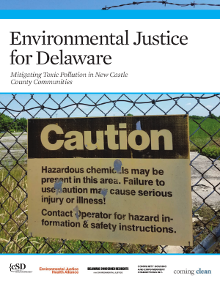

The report, titled ‘*Environmental Justice for Delaware’,* examines the health and safety risks for seven communities in an industrial corridor of Delaware’s New Castle County—an area that is home to major polluting industrial sources as well as facilities that use large quantities of toxic, flammable, or explosive chemicals. The communities studied in the report have higher ratios of people of color and/or people living in poverty than the Delaware average, and the report compares health risks in these communities to a nearby, predominantly White and more affluent community—as well as Delaware residents overall.

The risk of developing cancers and respiratory diseases in these neighborhoods was also compared to mapping information showing their proximity to industrial sources of pollution linked to these diseases.

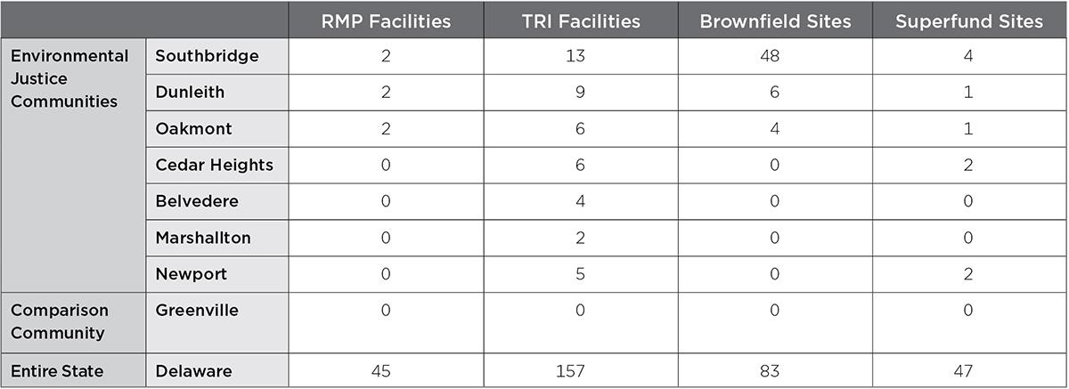

The report then considers the potential cumulative impacts from these multiple, overlapping health and safety issues:

* Risk of cancer and potential for respiratory illnesses affecting residents in the communities stemming from toxic outdoor air pollution;
* Proximity to facilities included in Environmental Protection Agency’s (EPA’s) Risk Management Program (RMP) that use large quantities of toxic, flammable, or explosive chemicals and pose a high risk of a catastrophic disaster to large numbers of nearby residents;
* Proximity to major industrial pollution sources that report their toxic chemical emissions in the EPA Toxics Release Inventory (TRI);
* And proximity to contaminated hazardous waste sites listed in EPA’s Brownfield and Superfund Programs.

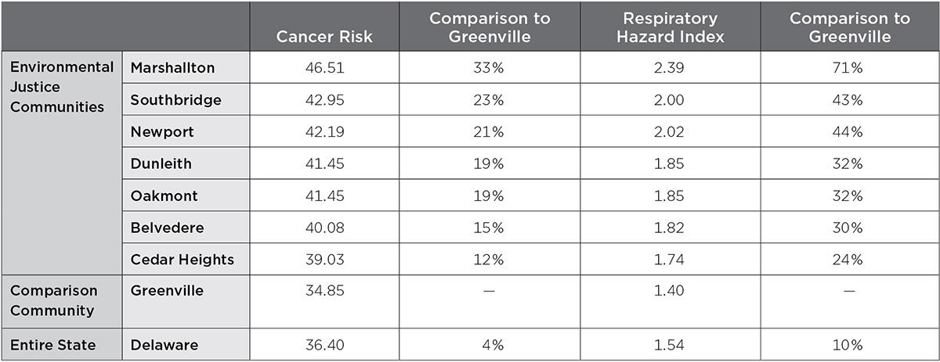

“For too long, people living in Southbridge and other communities facing environmental injustice have been told that the industries operating near our neighborhoods are safe, or that the health problems we see every day are the result of ‘lifestyle choices’, and the pollution we’ve endured isn’t harmful,” said **Octavia Dryden, with Delaware Concerned Residents for Environmental Justice.** She continued, “Now, with this report, we have yet more proof that we’re being taken advantage of, and the health of our community and our children is being sacrificed to industries who make money by passing their pollution on to us. This report shows that communities living on the fenceline of the chemical and fossil fuel industries support their profits with our bodies, and receive very little—if anything—in return.”

Mapping information conducted for this report found that the Southbridge neighborhood of Wilmington has 48 EPA listed Brownfields (more than half of all brownfields in Delaware), 13 facilities catalogued in EPA’s TRI, four EPA listed Superfund sites, two facilities which pose the risk of catastrophic disasters and are regulated under EPA’s RMP program, the Port of Wilmington which emits soot and other air pollutants, and multiple waste disposal facilities—all within the neighborhood or less than one mile away.

“Previous studies have shown that Black, Brown, and poor people are more likely to bear the consequences of dangerous chemical facilities and toxic industrial pollution [[1](http://comingcleaninc.org/whats-new/whos-in-danger-report), [2](https://www.foreffectivegov.org/shadow-of-danger)], but this new evidence highlights the environmental injustices occurring in Wilmington, DE, and illustrates the challenges faced by environmental justice communities across the nation,” said **Michele Roberts, Co-Coordinator of the Environmental Justice Health Alliance**. She continued, “Southbridge is at the epicenter of multiple, overlapping, and cumulative impacts from environmental pollution. Between contaminated sites, hazardous facilities, social and economic injustices, Southbridge is absolutely surrounded. It’s time for our decision-makers, from the Wilmington City Council all the way to Scott Pruitt and our federal Environmental Protection Agency—and everyone in between—to accept responsibility for the health and safety of all of their constituents, and not just those who look like them, live in neighborhoods like theirs, or can afford to to support their campaigns and careers. Our children's’ health and their futures are at stake.”

"This research shows clearly what neighbors in these communities already know--that they're unfairly facing higher health risks,” said **Gretchen Goldman, Research Director for the Center for Science and Democracy at the Union of Concerned Scientists**. She continued, “We need to listen to the communities and the facts, and we need to enact and enforce rules to protect their health and safety. Environmental justice has to be a priority."

“Far too many Delaware families are facing the cumulative impacts of decades of legacy contamination, active industrial pollution, racial and class discrimination, and climate change”, said **Stephanie Herron, Outreach Coordinator for the Delaware Sierra Club**. She continued, “The same unhealthy air pollution that’s making us sick is also diving our climate to brink of catastrophe. Sea level rise and more extreme weather are risk multipliers to our neighbors, who are already bearing the brunt of industrial pollution—as we’ve recently seen in Houston and locally here in Southbridge. Thankfully, our communities have solutions! We need to ***listen* to** and **work *with*** the communities highlighted in this report (and those who aren’t) to double renewable energy in Delaware in the next fifteen years, clean up transportation, address chronic flooding and make a ***just* transition** away from fossil fuels and dangerous chemicals that are putting our families at risk.”

The report urges local, state, and federal decision-makers to reduce harms related to industrial toxic pollution and mitigate its disproportionate impacts on environmental justice communities by:

* Requiring facilities which could release large amounts of poisonous gas or risk a catastrophic explosion to use inherently safer chemicals and processes where possible;
* Require these same facilities to share information with first-responders and local communities on their hazards and processes essential to emergency preparedness and disaster planning—so people may effectively prepare for any accidents;
* Require large chemical facilities to monitor and share information on all toxic emissions;
* Protect people by not allowing new hazardous chemical facilities near homes and schools, and prevent new homes and schools from being built near existing hazardous facilities;
* Require comprehensive assessment and mitigation plans focusing on the *cumulative* health-impacts of the multiple, overlapping exposures and risks these communities face;
* Strengthen enforcement of existing environmental and workplace health and safety regulations;
* Adopt and enforce strict motor vehicle emission standards and limit heavy duty truck traffic and idling in residential areas;
* Shift our energy and transportation infrastructure away from fossil-fuel systems and toward clean energy, which will help mitigate and reduce the disproportionate health impacts these communities suffer throughout the chemical and energy lifecycles. Reducing fossil-fuels use and shifting to clean energy can reduce the need for dangerous chemicals and processes and prevent disasters, cut industry and transportation related pollution linked to cancers and respiratory diseases, reduce the creation of contaminated sites, and create more vibrant, robust, and equitable communities.

A number of national, nonprofit organizations and local community groups held a press conference to release ‘*Environmental Justice for Delaware’* at a community center in Southbridge, Delaware, including the [Union Concerned Scientists](http://www.ucsusa.org/our-work/center-science-and-democracy), the [Environmental Justice Health Alliance](http://ej4all.org/), [Delaware Sierra Club](https://delaware.sierraclub.org/), and [Delaware Concerned Residents for Environmental Justice](https://www.facebook.com/DCR4EJ/). The event featured researchers and community experts who answered questions about the report and its significance.

###

The Environmental Justice Health Alliance (EJHA) organizes industry reform strategies for safer chemicals and clean energy that leave no community or worker behind.

The Union of Concerned Scientists puts rigorous, independent science to work to solve our planet's most pressing problems. Joining with people across the country, we combine technical analysis and effective advocacy to create innovative, practical solutions for a healthy, safe, and sustainable future.

Delaware Concerned Residents is a community-led grassroots organization founded out of the social justice ministry at the Episcopal Church of Saints Andrew and Matthew. A member of the Environmental Justice & Health Alliance, we adhere to the Principles of Environmental Justice and the Jemez Principles for Democratic Organizing. Our mission is “to inform and empower communities to take action to protect the fundamental rights to clean air, water, land and food.”

The Delaware Sierra Club is the statewide chapter of the Sierra Club in Delaware. The Sierra Club is the nation’s oldest and largest grassroots environmental advocacy organization. Our mission is “to explore, enjoy and protect the planet”. Local priorities include doubling renewable energy in Delaware, getting people outdoors, protecting and in critical areas like our Delaware Coastal Zone, and advancing the cause of Environmental Justice for all Delawareans.